**Project Title:** Virtual Machine management

**Objectives:**

* This project is to understand how to install a Virtual machine in windows
* This project is to learn how to configure Virtual machine
* This project is to learn how to install Linux in Virtual machine

**Methodology:**

Step 1: First I am downloading VirtualBox tool from web browser and I will install VirtualBox in Windows. VirtualBox is a free open source virtualization software developed by Oracle. It allows users to run multiple operating systems on single physical machine, simultaneously, without needing a reboot.

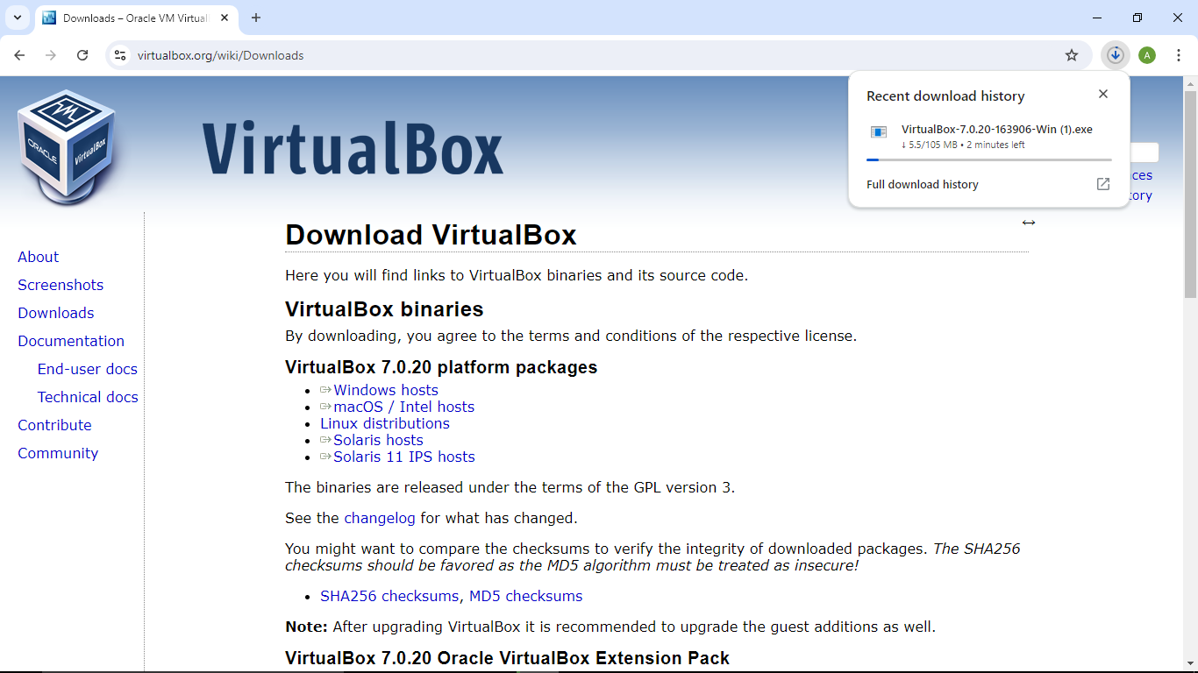

Step 2: Now I am downloading Linux ISO file from web browser. Linux have many distros like Ubuntu, Red hat, Fedora, Kali Linux but I am choosing Ubuntu here.

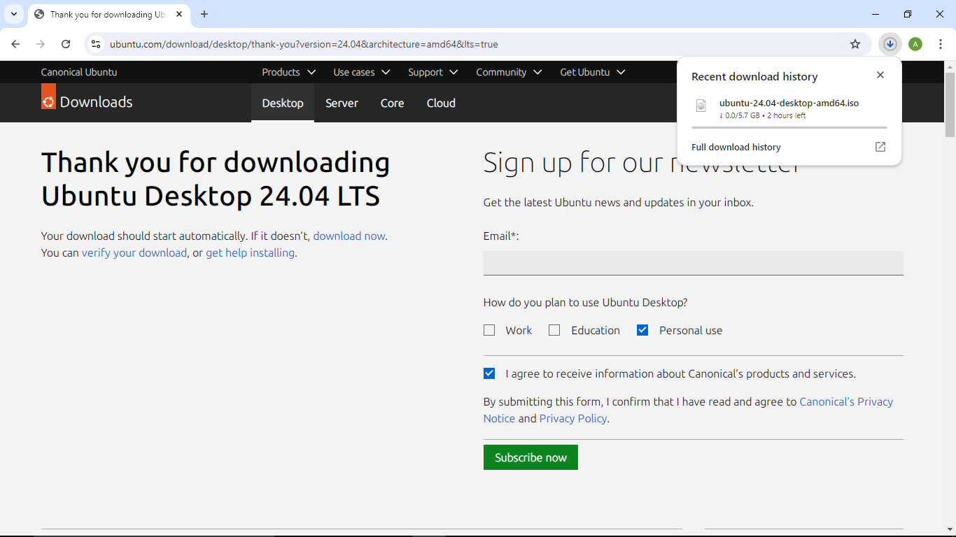

Step 3: Next I have launched VirtualBox after installation. I have clicked on ‘New’ button in VirtualBox to create a new virtual machine. I have entered a name for virtual machine. Selected a folder where files of virtual machine will be stored. Selected Ubuntu ISO file in ISO image section. And now I have to click on Next.

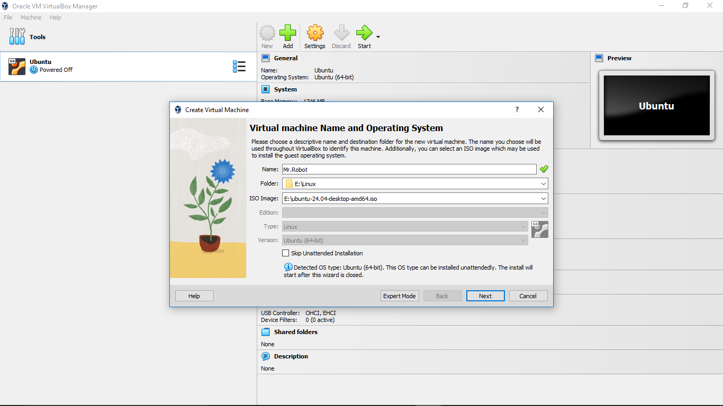

Step 4: I am selecting the amount of RAM that will be allocate to the Virtual machine. Also setting the no of CPU core that will be allocate to the Virtual machine. It is recommended not to cross the green line here.

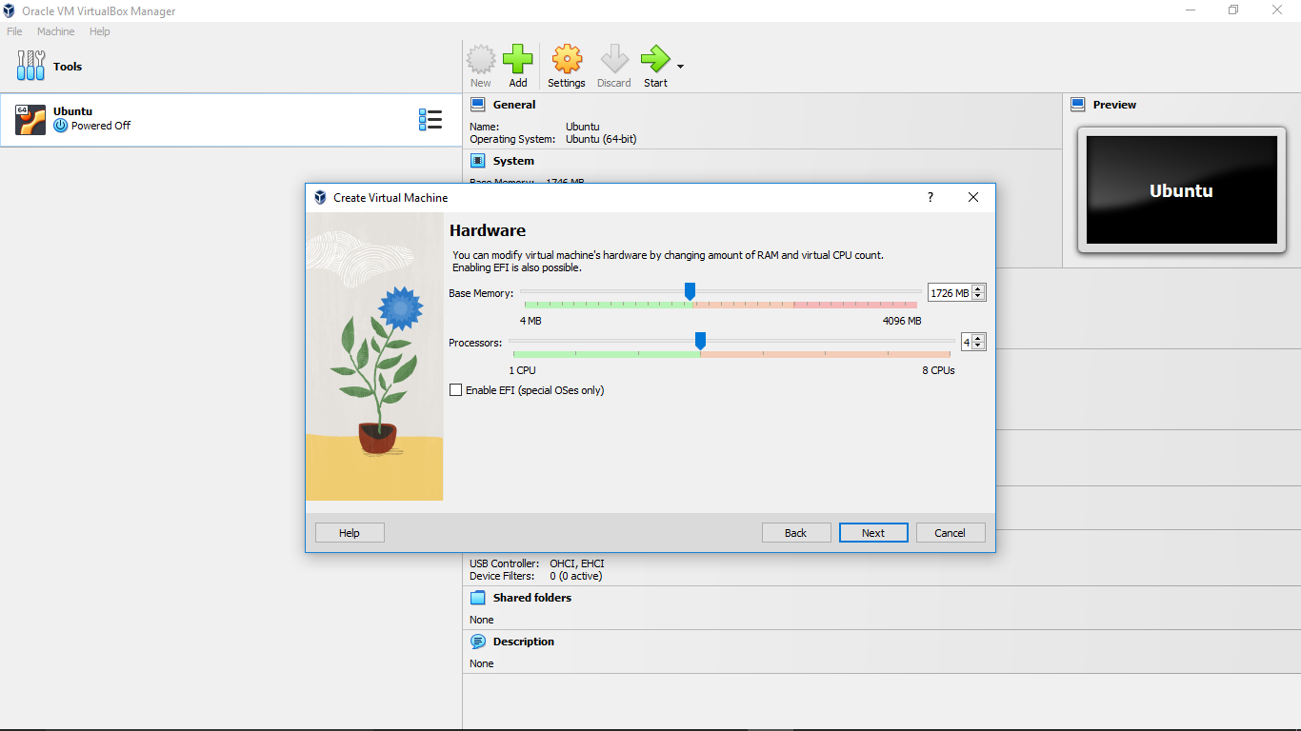

Step 5: Now I am setting the amount of Hard Disk space that will be allocate to the Virtual machine. It is recommended to choose at least 20 GB of Hard Disk space.

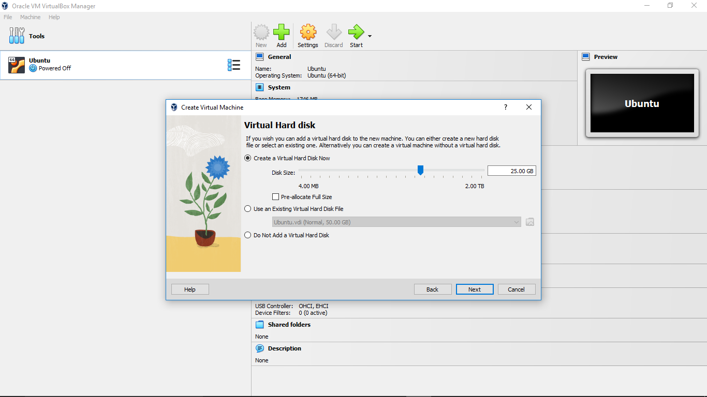

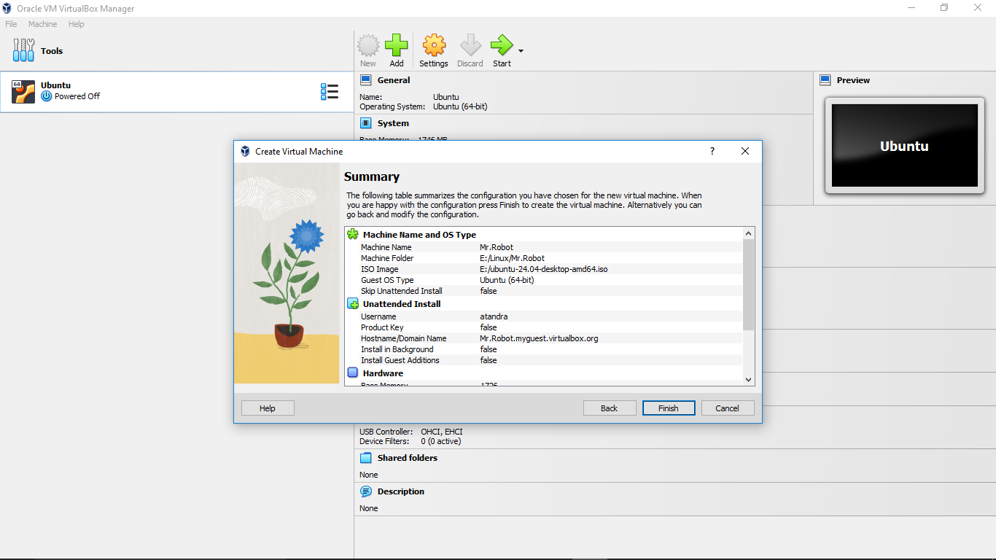

Now it is displaying a summary of my Virtual Machine, now I have to click on ‘Finish’ to move forward.

Step 6: Once I have created this machine I will be able to see this new machine in the list here, which is ‘Mr.Robot’ so I have selected the machine and clicked on ‘Settings’ option. Now I had to go to ‘Storage’ section and clicked on ‘Empty’ option under ‘Controller: IDE’ and selected the Ubuntu ISO file in ‘Optical Drive’ section now I have to click on ‘OK’.

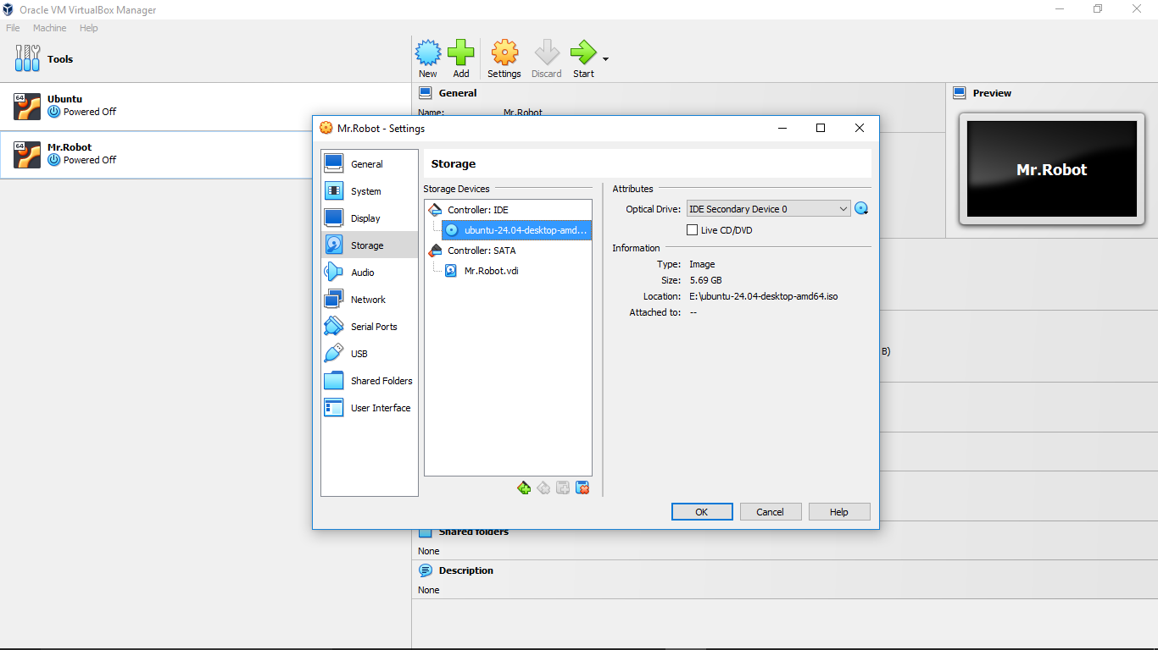

Step 7: Now again I have to select my new machine from the list and have to click on ‘Start’ option. It is mandatory to turn on ‘Virtualization’ features from BIOS in my computer just before I run Linux in VirtualBox.

To turn on ‘Virtualization’ I have entered into my BIOS, by pressing ‘F2’ or ‘F12’ or ‘Delete’ key after restarting my computer and before log in screen loads in my main system.

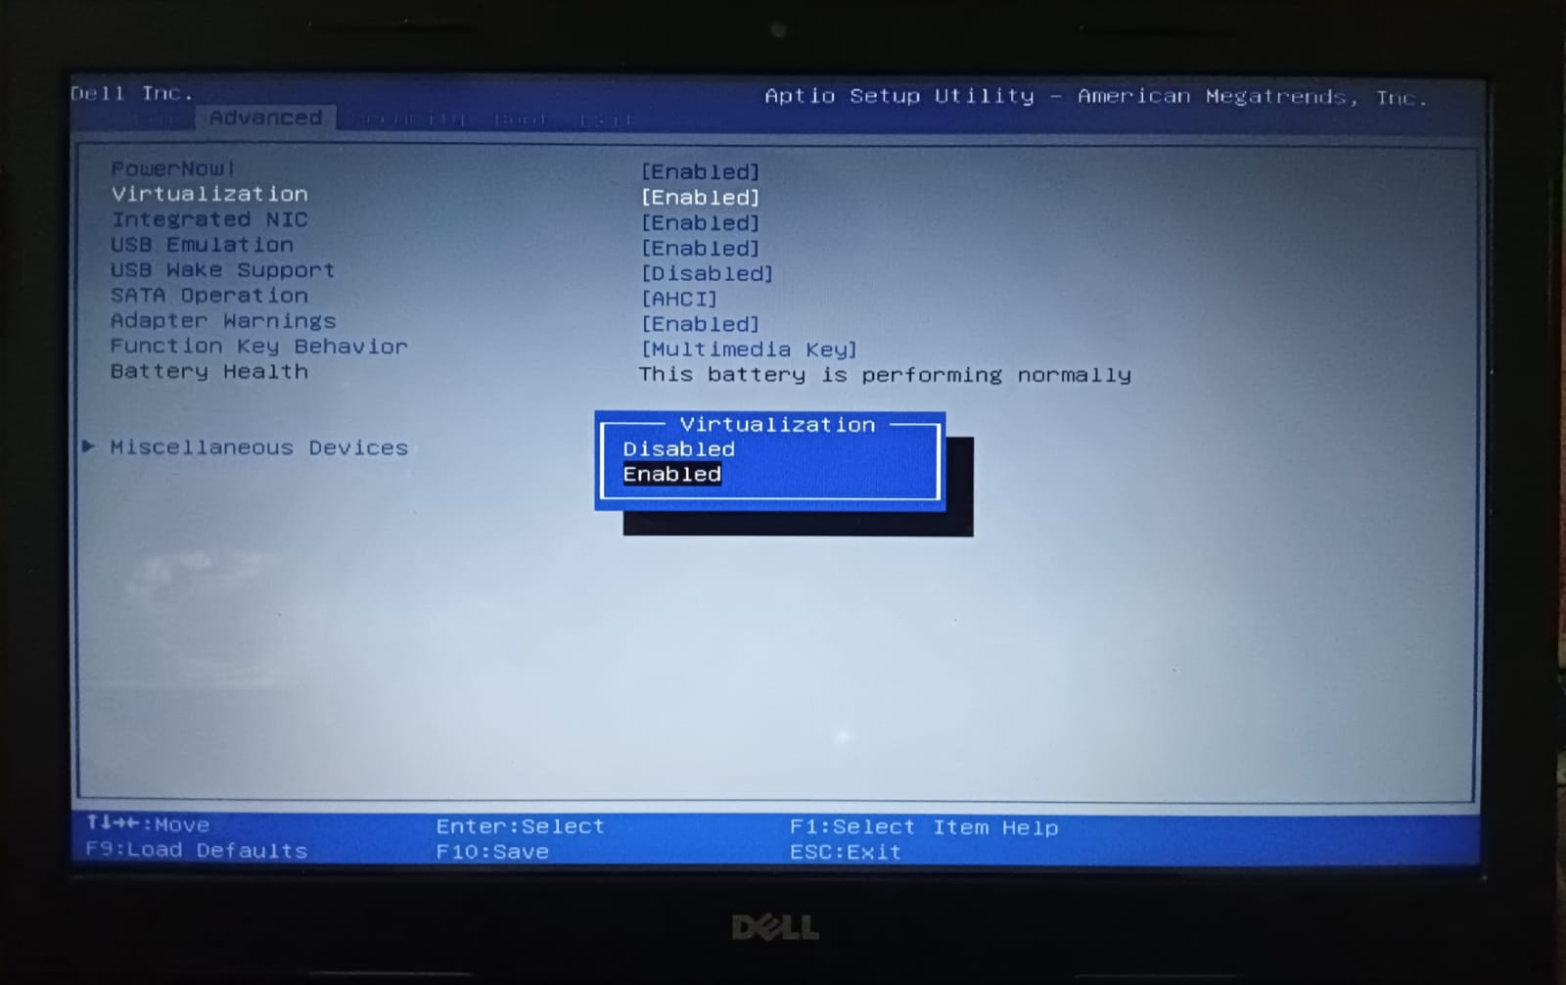

Step 8: Now an interface is appearing for installing Linux (Ubuntu).

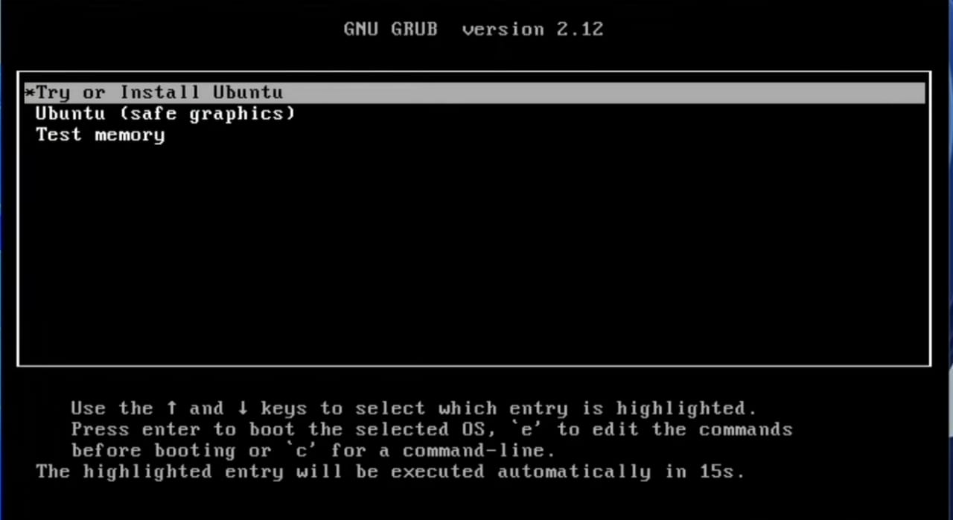

Step 9: Next an interface is appearing for selecting Language.

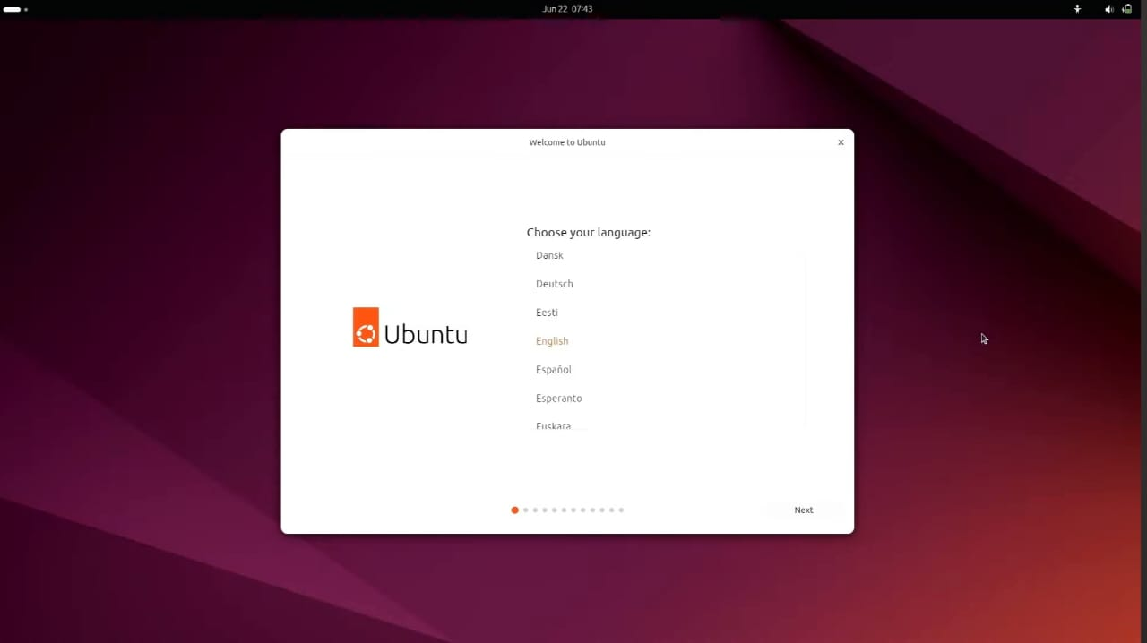

Step 10: Now an interface is appearing for Installing Ubuntu, here I have to click on ‘Install ubuntu’ and click on ‘Next’

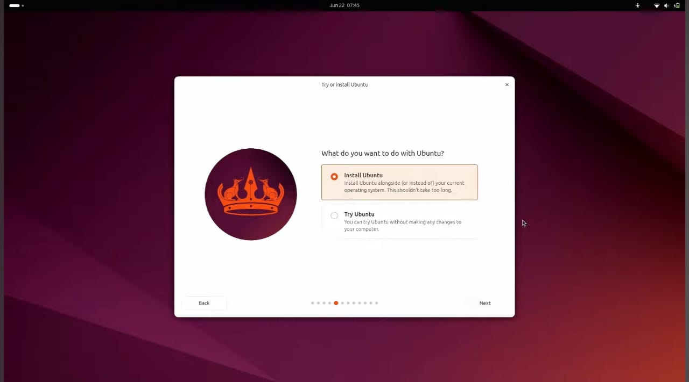

Step 11: Here I want a clean and fresh installation of Ubuntu so I am selecting ‘Erase disk and install Ubuntu’ or if I want to make disk partition then I had to select ‘Manual installation’

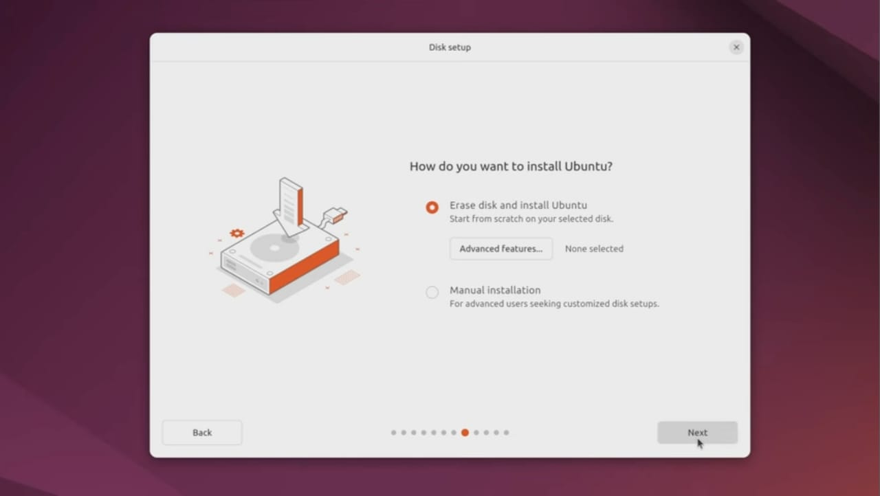

Step 12: Here I have to put my name, computer name, also my username & password.

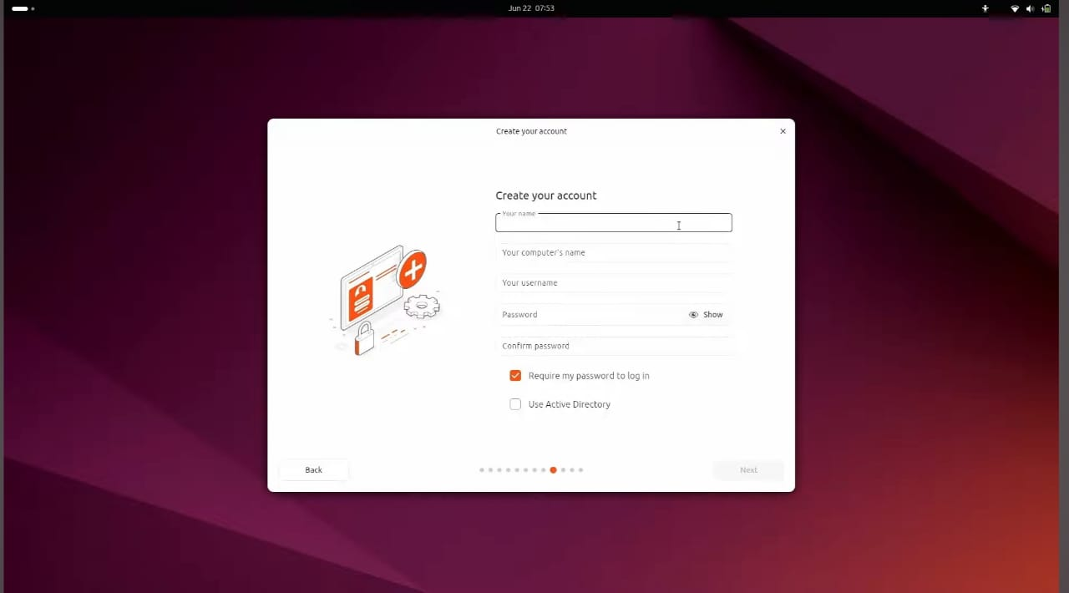

Step 13: Finally, installation start and it will take some time to complete the installation.

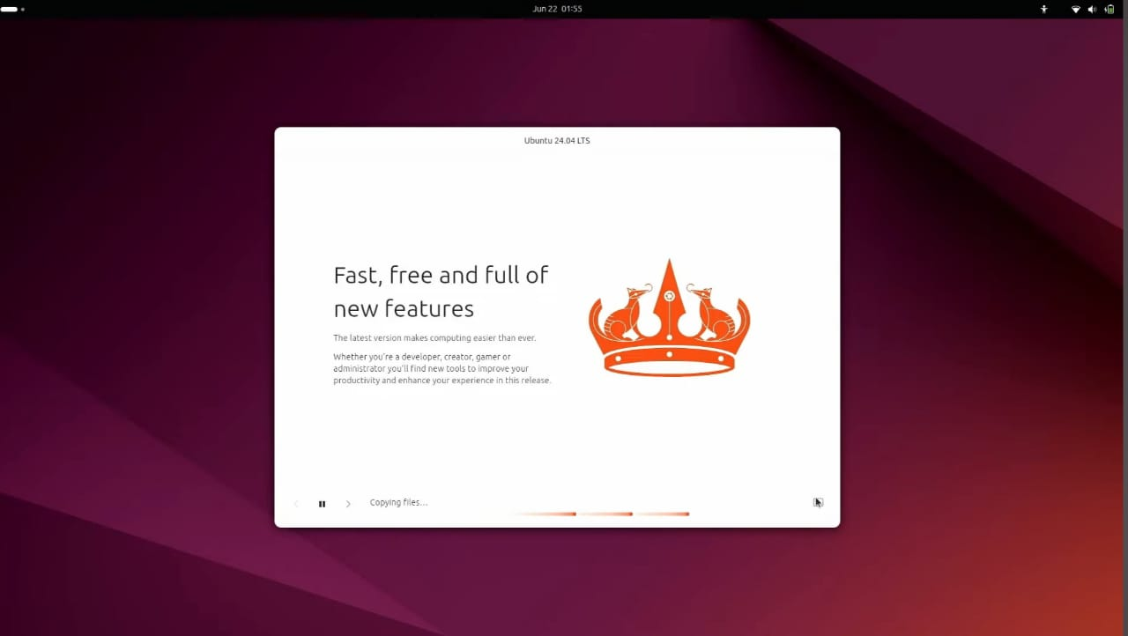

Step 14: Now I have to type my username & password for log in to my system.

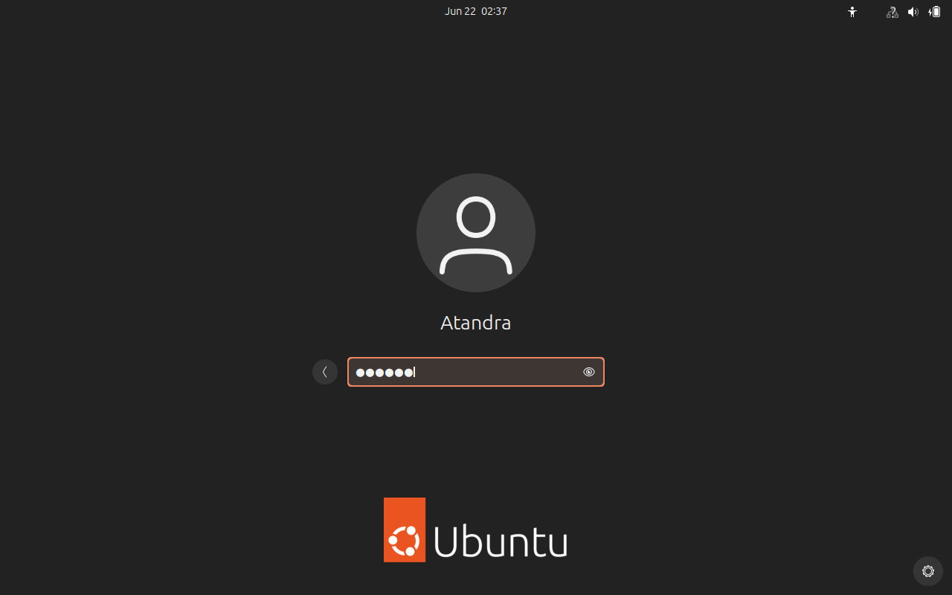

Step 15: Finally, I am logged into my system.

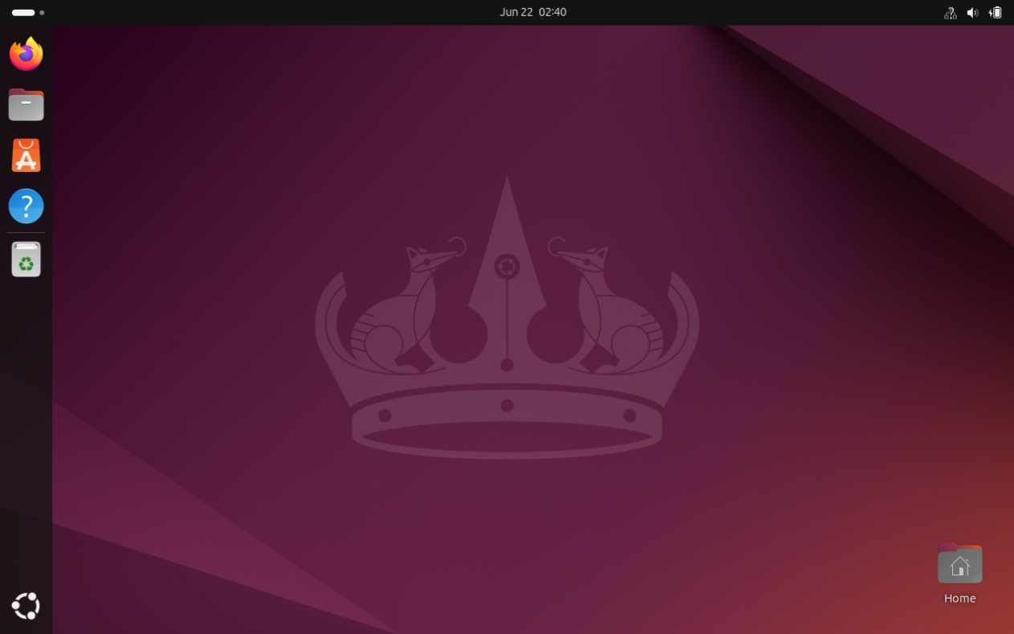

**Conclusion:**

By completing this project, I will have successfully installed a Linux operating system in a virtual machine, providing a safe environment to explore and experiment with Linux without modifying my primary system.

Virtual machine is excellent tool for learning, development & testing, offering flexibility to run multiple operating systems on one physical machine.